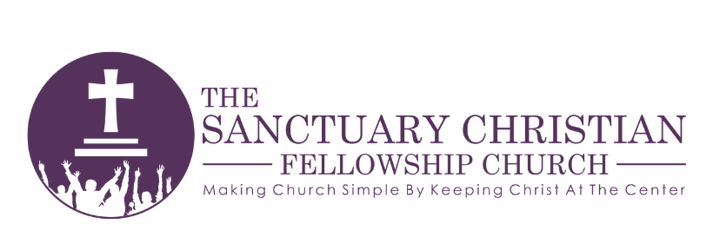
CHURCH COUNSELING REQUEST

Last Name | First Name |  | Date of Birth
Street Address
City | State |  | Zip Code
Phone: Work | Home |  | Other
____Male ____Female ____Single ____Married ____Divorced ____Widowed ____Separated
Home Church Name, Pastor’s Name, How long attended?
Do you attend regularly? ___Yes ___No Have you had previous counseling? ___Yes ___No
If you have had previous counseling, with whom?
How long? |  | Reason for termination:
Please describe the reason you are seeking counseling? i.e. Financial, Marital, Pre-Marital, Other
What goals do you hope to achieve through counseling?
I do hereby release, forever discharge and hold harmless The Sanctuary Christian Fellowship Church and the directors / pastors / and counselors thereof, from any and all liability, claims, or demands for personal injury, sickness or death. I understand that the counseling I receive is not from LICENSED PSYCHOLOGISTS, OR PSYCHIATRISTS. I simply will receive counseling based on the Word of God; and an opportunity for prayer led by the Holy Spirit.
Signature_______________________________________________________ Date:_______________
OFFICE USE ONLY
Date: Counselor:____________________________
Request Approved by:___________________________________________________________________

